1. Package yang di gunakan sebagai berikut:
2. Package di bagian frontend:
3. +-- @fortawesome/fontawesome-svg-core@6.7.2
4. +-- @fortawesome/free-solid-svg-icons@6.7.2
5. +-- @fortawesome/react-fontawesome@0.2.3
6. +-- @heroicons/react@2.2.0
7. +-- @heroui/react@2.8.2
8. +-- @testing-library/dom@10.4.1
9. +-- @testing-library/jest-dom@6.6.4
10. +-- @testing-library/react@16.3.0
11. +-- @testing-library/user-event@13.5.0
12. +-- aos@2.3.4
13. +-- autoprefixer@10.4.21
14. +-- axios@1.11.0
15. +-- flowbite-react@0.12.7
16. +-- framer-motion@12.23.12
17. +-- jwt-decode@4.0.0
18. +-- leaflet-geosearch@4.2.0
19. +-- leaflet@1.9.4
20. +-- lucide-react@0.539.0
21. +-- postcss@8.5.6
22. +-- react-calendar@6.0.0
23. +-- react-datepicker@8.4.0
24. +-- react-dom@19.1.1
25. +-- react-icons@5.5.0
26. +-- react-intersection-observer@9.16.0
27. +-- react-leaflet@5.0.0
28. +-- react-responsive-carousel@3.2.23
29. +-- react-router-dom@6.30.1
30. +-- react-scripts@5.0.1
31. +-- react-select@5.10.2
32. +-- react-toastify@11.0.5
33. +-- react@19.1.1
34. +-- recharts@3.1.2
35. +-- sweetalert2@11.22.5
36. +-- tailwindcss@3.4.3
37. `-- web-vitals@2.1.4
38. Package di bagian Backend:
39. filippo.io/edwards25519 v1.1.0
40. github.com/bytedance/sonic v1.13.3
41. github.com/bytedance/sonic/loader v0.2.4
42. github.com/cloudwego/base64x v0.1.5
43. github.com/cloudwego/iasm v0.2.0
44. github.com/creack/pty v1.1.9
45. github.com/davecgh/go-spew v1.1.1
46. github.com/dgrijalva/jwt-go v3.2.0+incompatible
47. github.com/gabriel-vasile/mimetype v1.4.9
48. github.com/gin-contrib/cors v1.7.6
49. github.com/gin-contrib/sse v1.1.0
50. github.com/gin-gonic/gin v1.10.1
51. github.com/go-playground/assert/v2 v2.2.0
52. github.com/go-playground/locales v0.14.1
53. github.com/go-playground/universal-translator v0.18.1
54. github.com/go-playground/validator/v10 v10.26.0
55. github.com/go-sql-driver/mysql v1.8.1
56. github.com/goccy/go-json v0.10.5
57. github.com/golang/protobuf v1.5.0
58. github.com/google/go-cmp v0.7.0
59. github.com/google/gofuzz v1.0.0
60. github.com/jinzhu/inflection v1.0.0
61. github.com/jinzhu/now v1.1.5
62. github.com/json-iterator/go v1.1.12
63. github.com/klauspost/cpuid/v2 v2.2.10
64. github.com/knz/go-libedit v1.10.1
65. github.com/kr/pretty v0.3.0
66. github.com/kr/text v0.2.0
67. github.com/leodido/go-urn v1.4.0
68. github.com/mattn/go-isatty v0.0.20
69. github.com/modern-go/concurrent v0.0.0-20180306012644-bacd9c7ef1dd
70. github.com/modern-go/reflect2 v1.0.2
71. github.com/pelletier/go-toml/v2 v2.2.4
72. github.com/pmezard/go-difflib v1.0.0
73. github.com/rogpeppe/go-internal v1.8.0
74. github.com/stretchr/objx v0.5.0
75. github.com/stretchr/testify v1.10.0
76. github.com/twitchyliquid64/golang-asm v0.15.1
77. github.com/ugorji/go/codec v1.3.0
78. golang.org/x/arch v0.18.0
79. golang.org/x/crypto v0.39.0
80. golang.org/x/mod v0.25.0
81. golang.org/x/net v0.41.0
82. golang.org/x/sync v0.15.0
83. golang.org/x/sys v0.33.0
84. golang.org/x/term v0.32.0
85. golang.org/x/text v0.26.0
86. golang.org/x/tools v0.33.0
87. golang.org/x/xerrors v0.0.0-20191204190536-9bdfabe68543
88. google.golang.org/protobuf v1.36.6
89. gopkg.in/check.v1 v1.0.0-20201130134442-10cb98267c6c
90. gopkg.in/yaml.v3 v3.0.1
91. gorm.io/driver/mysql v1.6.0
92. gorm.io/gorm v1.30.0
93. nullprogram.com/x/optparse v1.0.0
94. rsc.io/pdf v0.1.1
95. Kekurangan dan saran penambahan fitur:
96. Pada bagian frontend:
97. wbs ( WBS adalah cara resmi dan terlindungi bagi masyarakat atau pegawai untuk melaporkan kasus korupsi atau pelanggaran lainnya melalui formulir pengaduan khusus )
98. -notifikasi ( notifikasi status pengaduan ketika aduan anda terproses maka akan ad notif )
99. pasang profil ( user bisa mengganti foto profil)
100. pada bagian Backend:
101. Menu utama pada Superadmin:
102. Dashboard:

* Total Aduan fitur WBS
* Jumlah kategori
* Jumlah OPD
* Bard chard aduan terbanyak berdasarkan kategori

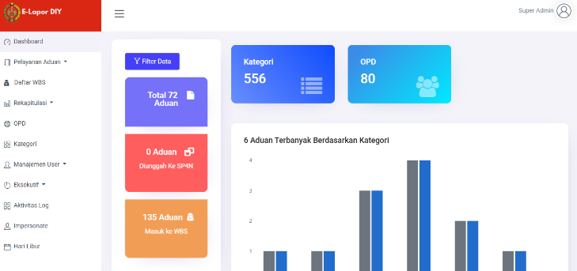

1. Fitur Daftar WBS
2. Submenu Fitur Repitulasi

* Jumlah aduan per periode
* Jumlah aduan per kategori
* Rekap detail aduan
* Rekap sederhana aduan
* OPD responsive
* Tren aduan
* Jumlah aduan SP4N
* Rekap WBS

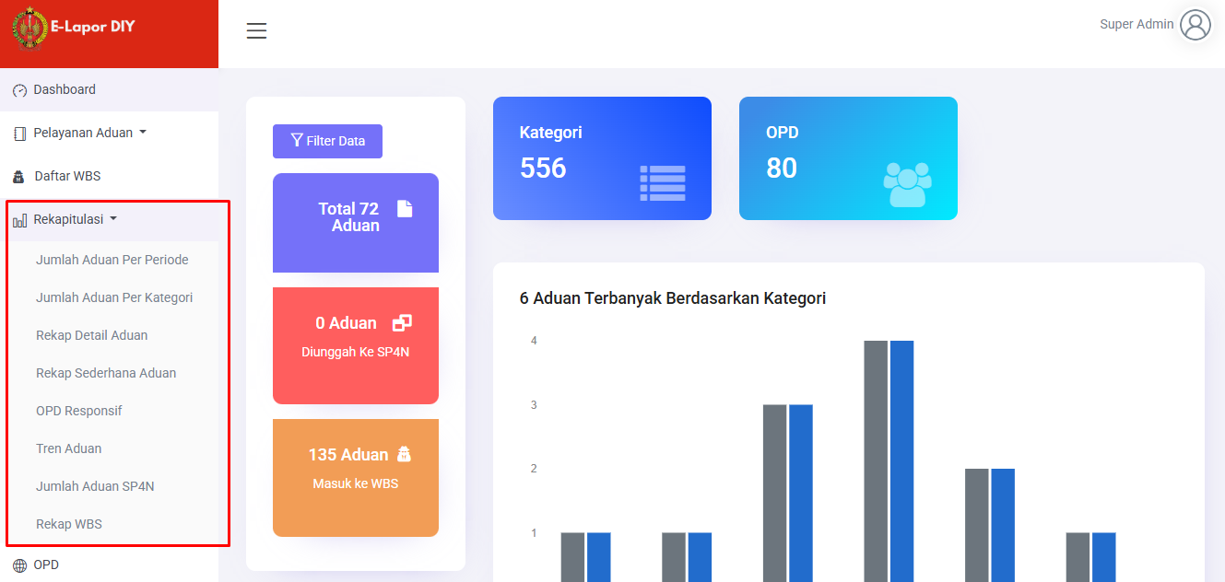

1. Submenu Manajemen user

* Permissions
* Role
* User

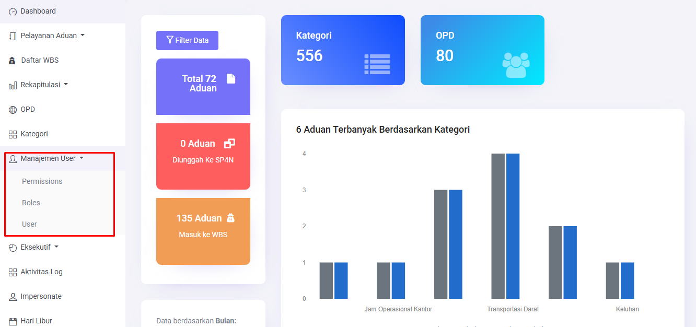

1. Fitur eksekutif dan submenunya

* Kategori
* OPD
* Wilayah

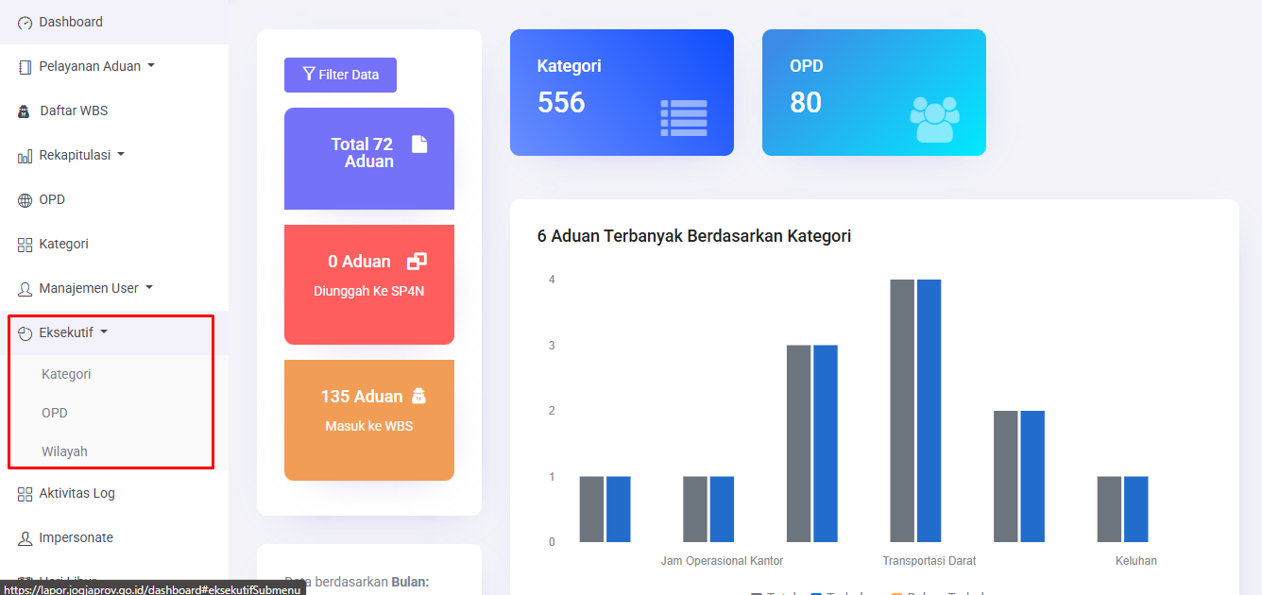

1. Fitur aktivitas Log

* Detail log

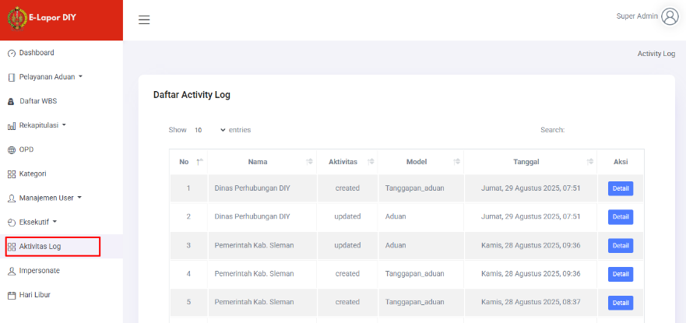

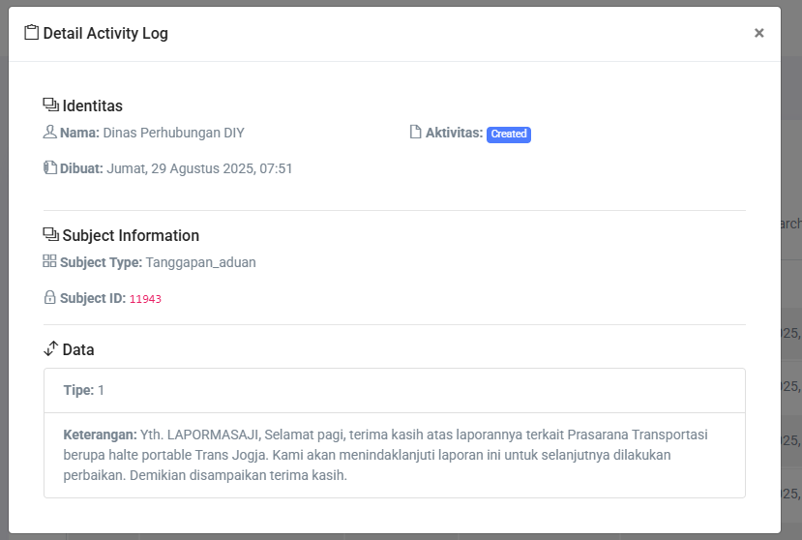

1. Fitur impersonet

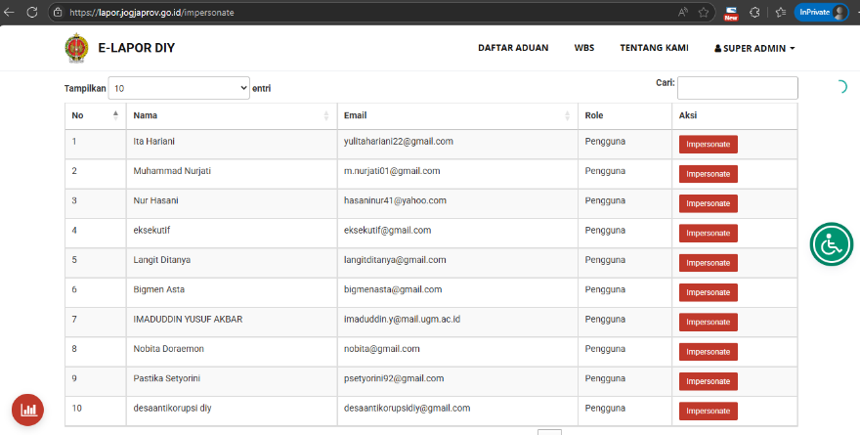

1. Fitur libur

